Employment Application
Pre-Employment Form
P O Box 108
OAMARU 9444
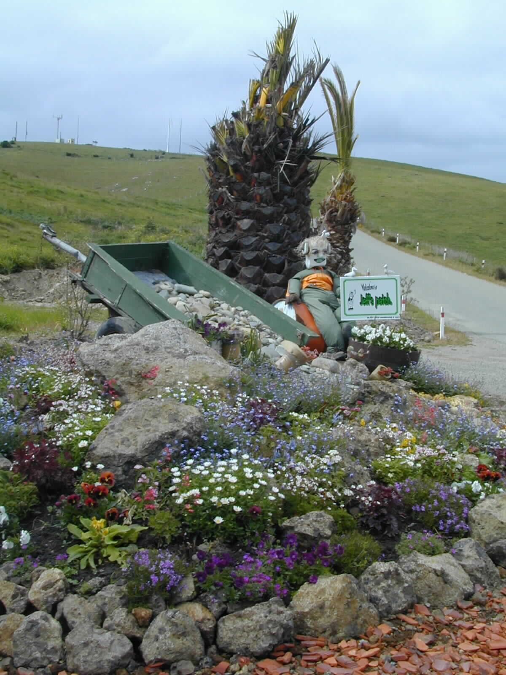
Ph: 433 0240
Landfill
Work
Guidelines
Landfill
Work
Guidelines
Fax: 434 1270
e-mail: info@whitestone.co.nz
Note
- Applicants are informed that the company has no job vacancies at present and that it is company policy to only make further contact if the application is successful.
- The company has a drug and alcohol policy which will require pre employment screening and/or medical examination of the applicant.
Note 1. Applicants are informed that the Company has no job vacancies at present and that it is Company
policy to only make further contact if the application is successful.
2. The Company has a drug and alcohol policy which may require pre employment sereening and or
medical examination of the applicant.
EMPLOYMENT
APPLICATION
P.O.BOX 108
OAMARU
PHONE 434 8870
FAX 434 1270
Please complete Health Questionnaire on Reverse of this form

Issue Date 13-May-2003 File Ref. Employme
Date of Application
Name
Address
Date of Birth
Contact  Where can we contact you | Phone number |  |  | Cell or other Phone number
Driver Licences Classes & Endorsements
We need to know what vehicles you can operate

Have you ever had any criminal / legal convictions? Insolvency? Bankruptcy? Yes / No
If ‘yes’, please give details:
Qualifications: Including any relevant Unit Standards or National Certificates from Industry Training Organisations
ie: Contractors, Bitumen, Extractives, Plumbers and Drainlayers, Water and Waste Water, Motor Trades
Work Experience: |  | Please list three previous employers and your experience
Employer |  | Position Held / Experience |  |  | Year
Current Employment Status:
ie When would you be able to start
Position Preferred:

Please complete the Health Questionnaire on reverse of this form
Health Questionnaire
Note: The Accident Rehabilitation and Compensation Insurance Act 1992, Section 7 (6) states that an applicant knowingly misrepresenting themselves as not suffering from personal injury due to gradual process will not be entitled to compensation and rehabilitation.

Have you ever had an ACC claim?
If yes please explain:

Were you absent from work during the past year?
If yes please explain:

Have you ever had medical treatment for,
or do you suffer from: YES: NO:
Back Strain or Pain
Asthma
Hearing Loss
Occupational Overuse Syndrome
Sensitivity to chemicals or other materials

Is there anything else about your health or physical condition which may affect your ability to perform the duties proposed? If yes please specify:
Please sign indicating all information is true and correct and that you give consent for:
Whitestone Contracting Limited, or its representative, to contact your previous employer.
By signing this form you give Whitestone Contracting Limited:
- Permission to check that the qualifications and licences provided to us by you are correct
- Permission for a police check to be carried out.

Signature: Date:

